{mlang en}
Manual
How to create a Moodle MC quiz using a prompt?

{mlang en}

Step 1:
Correct prompt (= input in ChatGPT)
Create a Moodle xml for the following question:
Which of the following is a potential?
a Force density
b A gradient
c A quantity whose gradient has a descriptive meaning

The correct answer is "c".
Exclude the answer lettering in the xml file.

Add the following tags: Fluid mechanics, theory
Omit general feedback.

The name of the question is "Potential - theory question".

Step 2:
Copy the code from ChatGPT. Paste it into an editor program. Save as .xml.

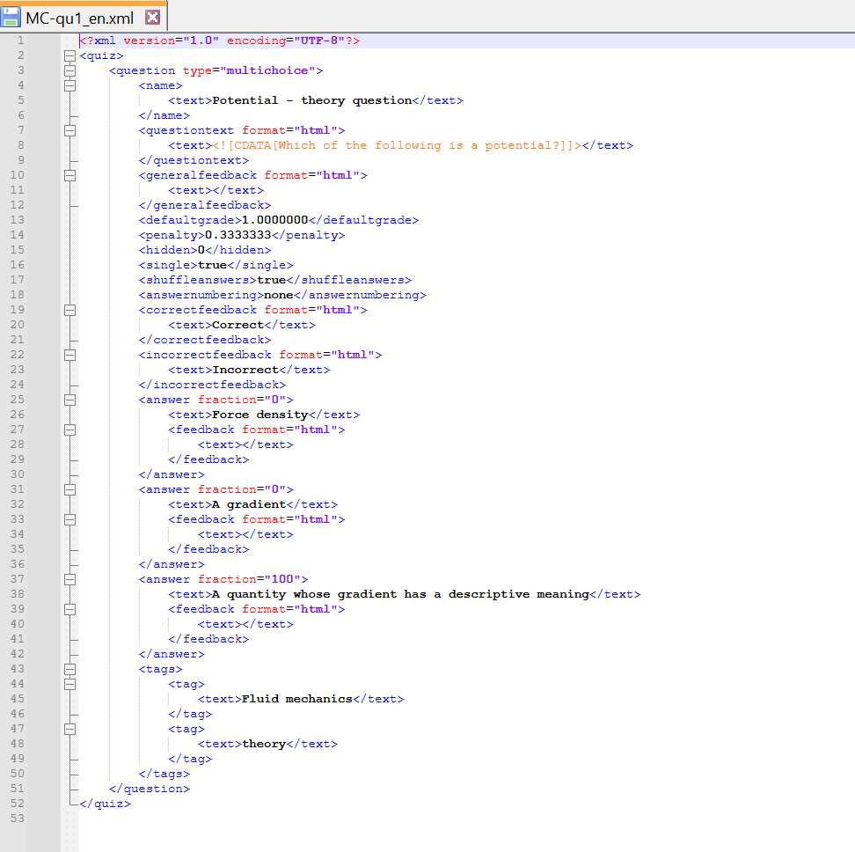

Step 3:
Moodle Questionbank / Import

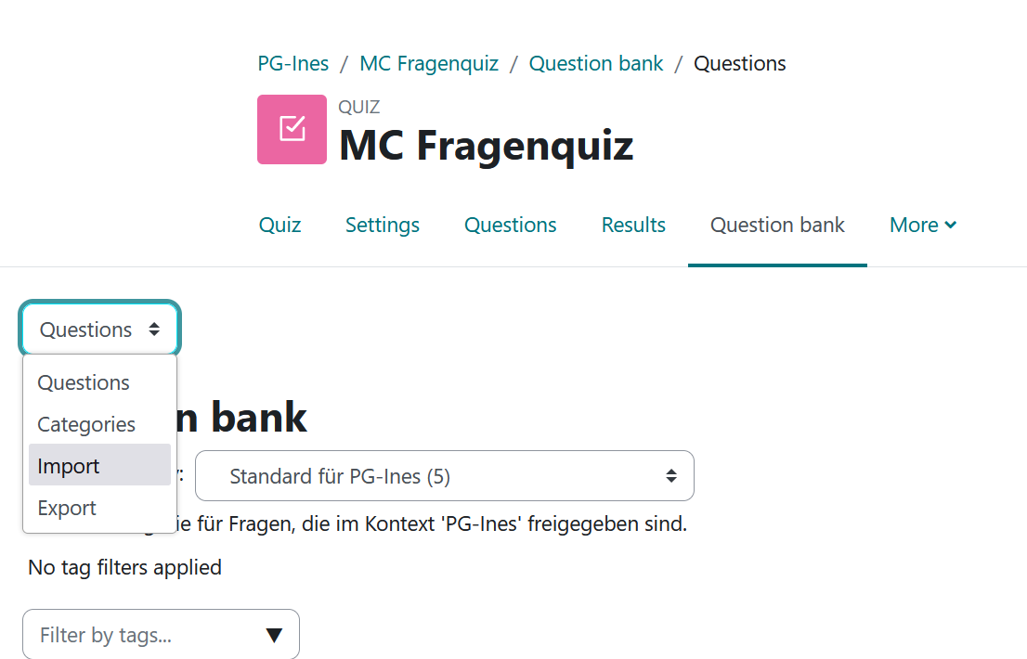

Choose the Moodle-XML-format

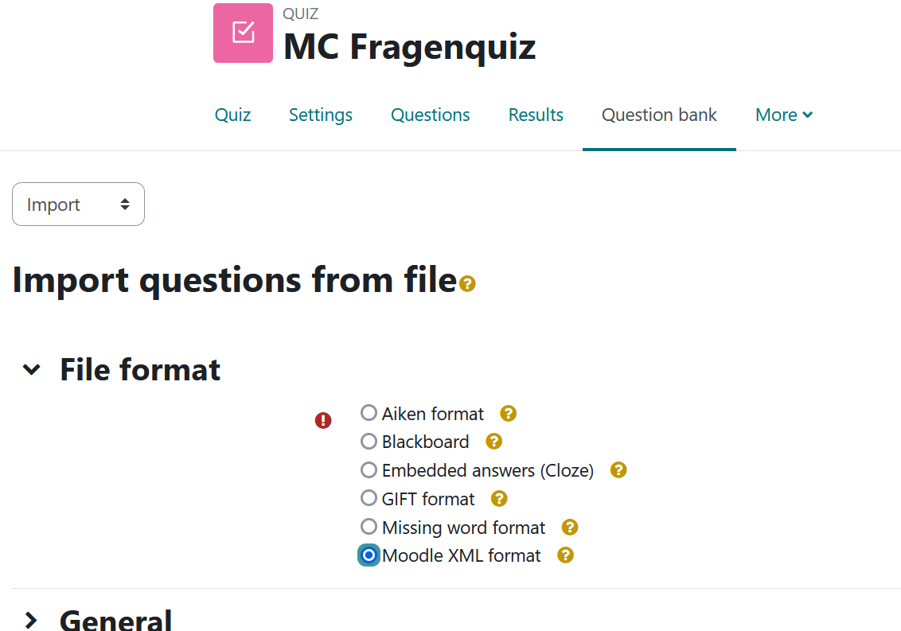

Click on "Browse" and select the .xml file. Click “Import”.

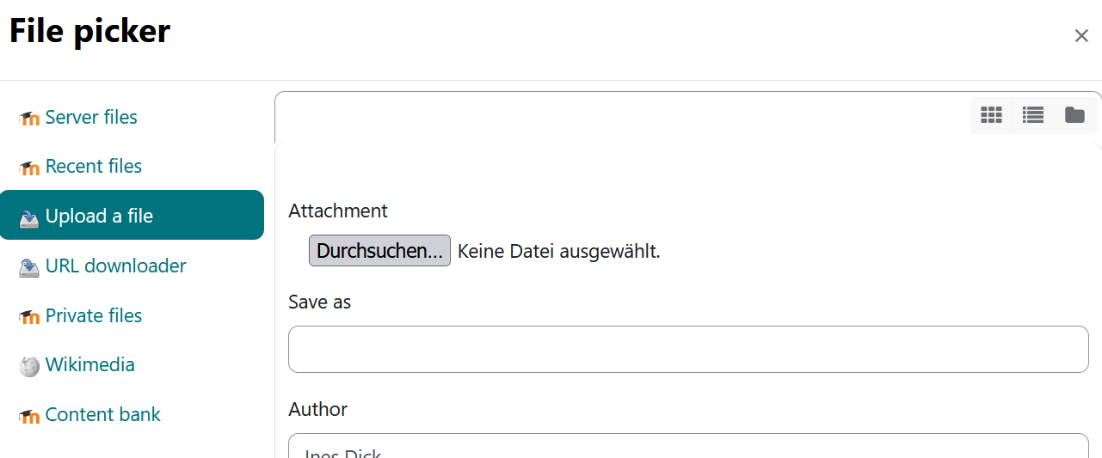

Then click on continue.
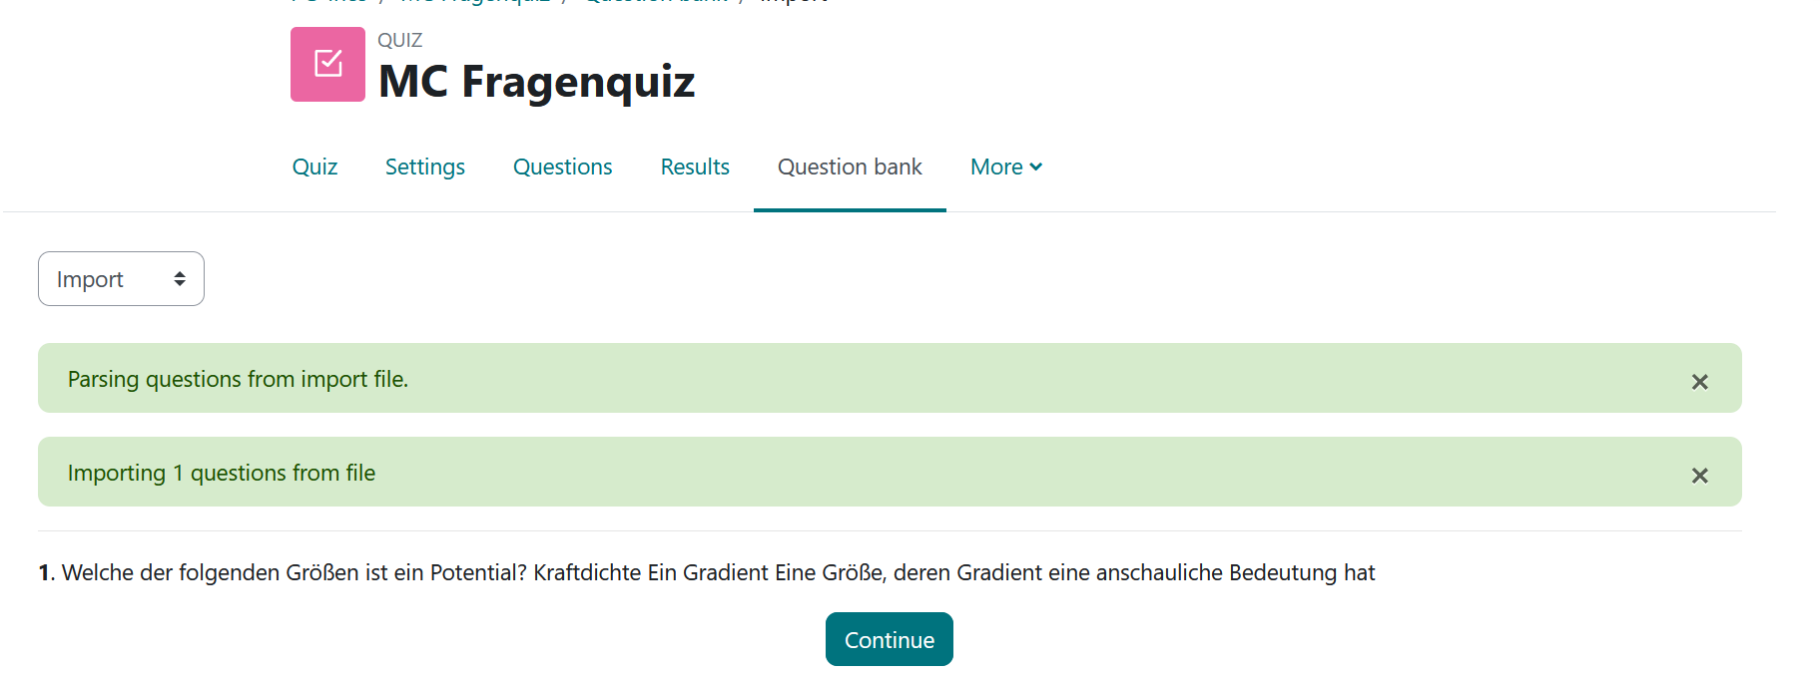

Step 4:
Go to the quiz section of your course. Click on "Add question" or „Continue the last preview“.

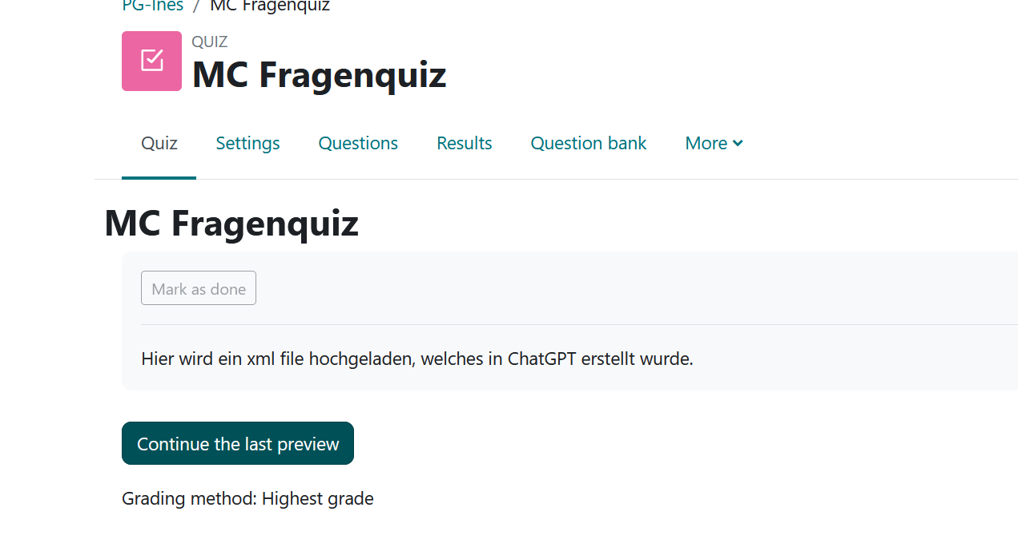

Under “Questions” you can click "add" and "+from question bank"
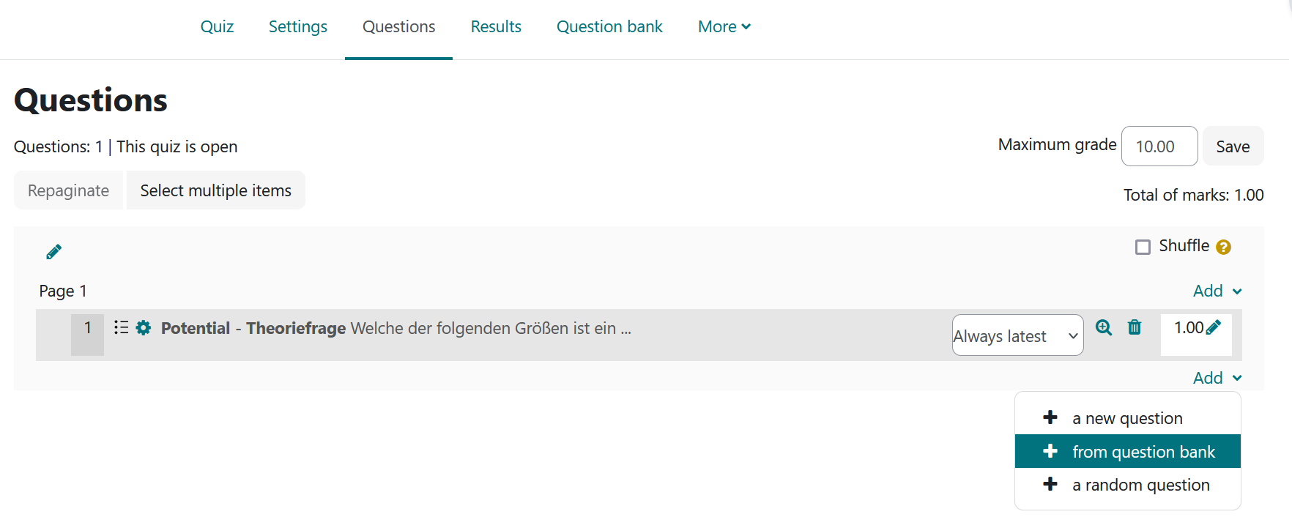

Now select the correct question from the list of questions. This will be ticked.
Click on "Add selected question to test".

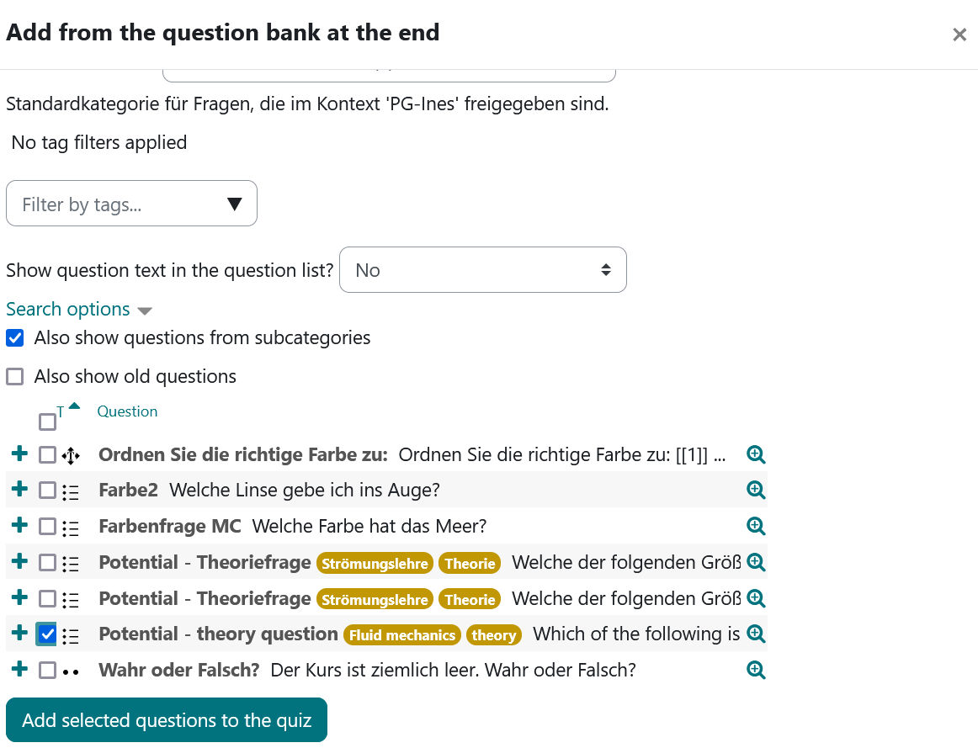

Test preview:
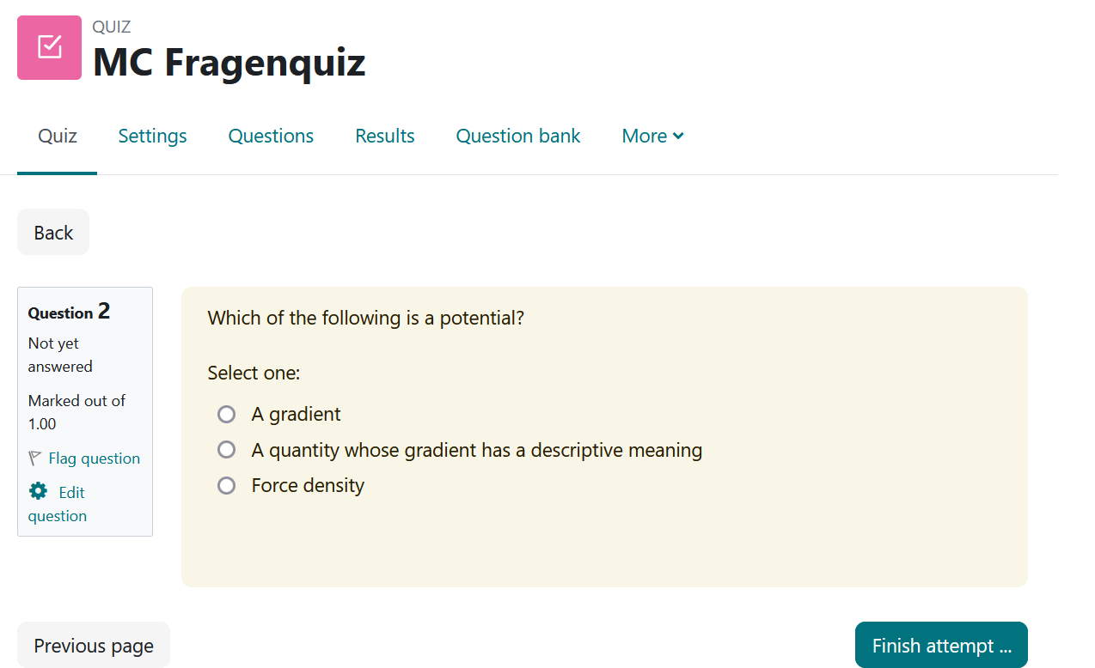

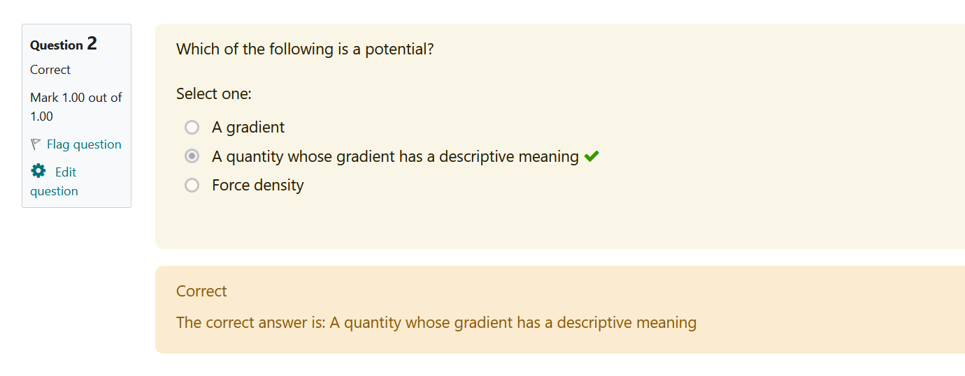
{mlang}

