Help with:
Curriculum creation, quality assurance and course analysis
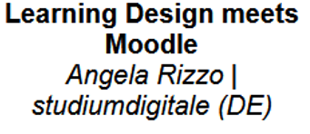
https://learning-design.eu/en/index
Analytics and research teachers!!!
Fill in a wiki with content. There's a lot to enter to get graphics out
Ease of work
Help teachers plan their teaching.

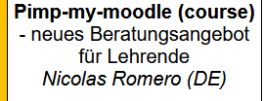
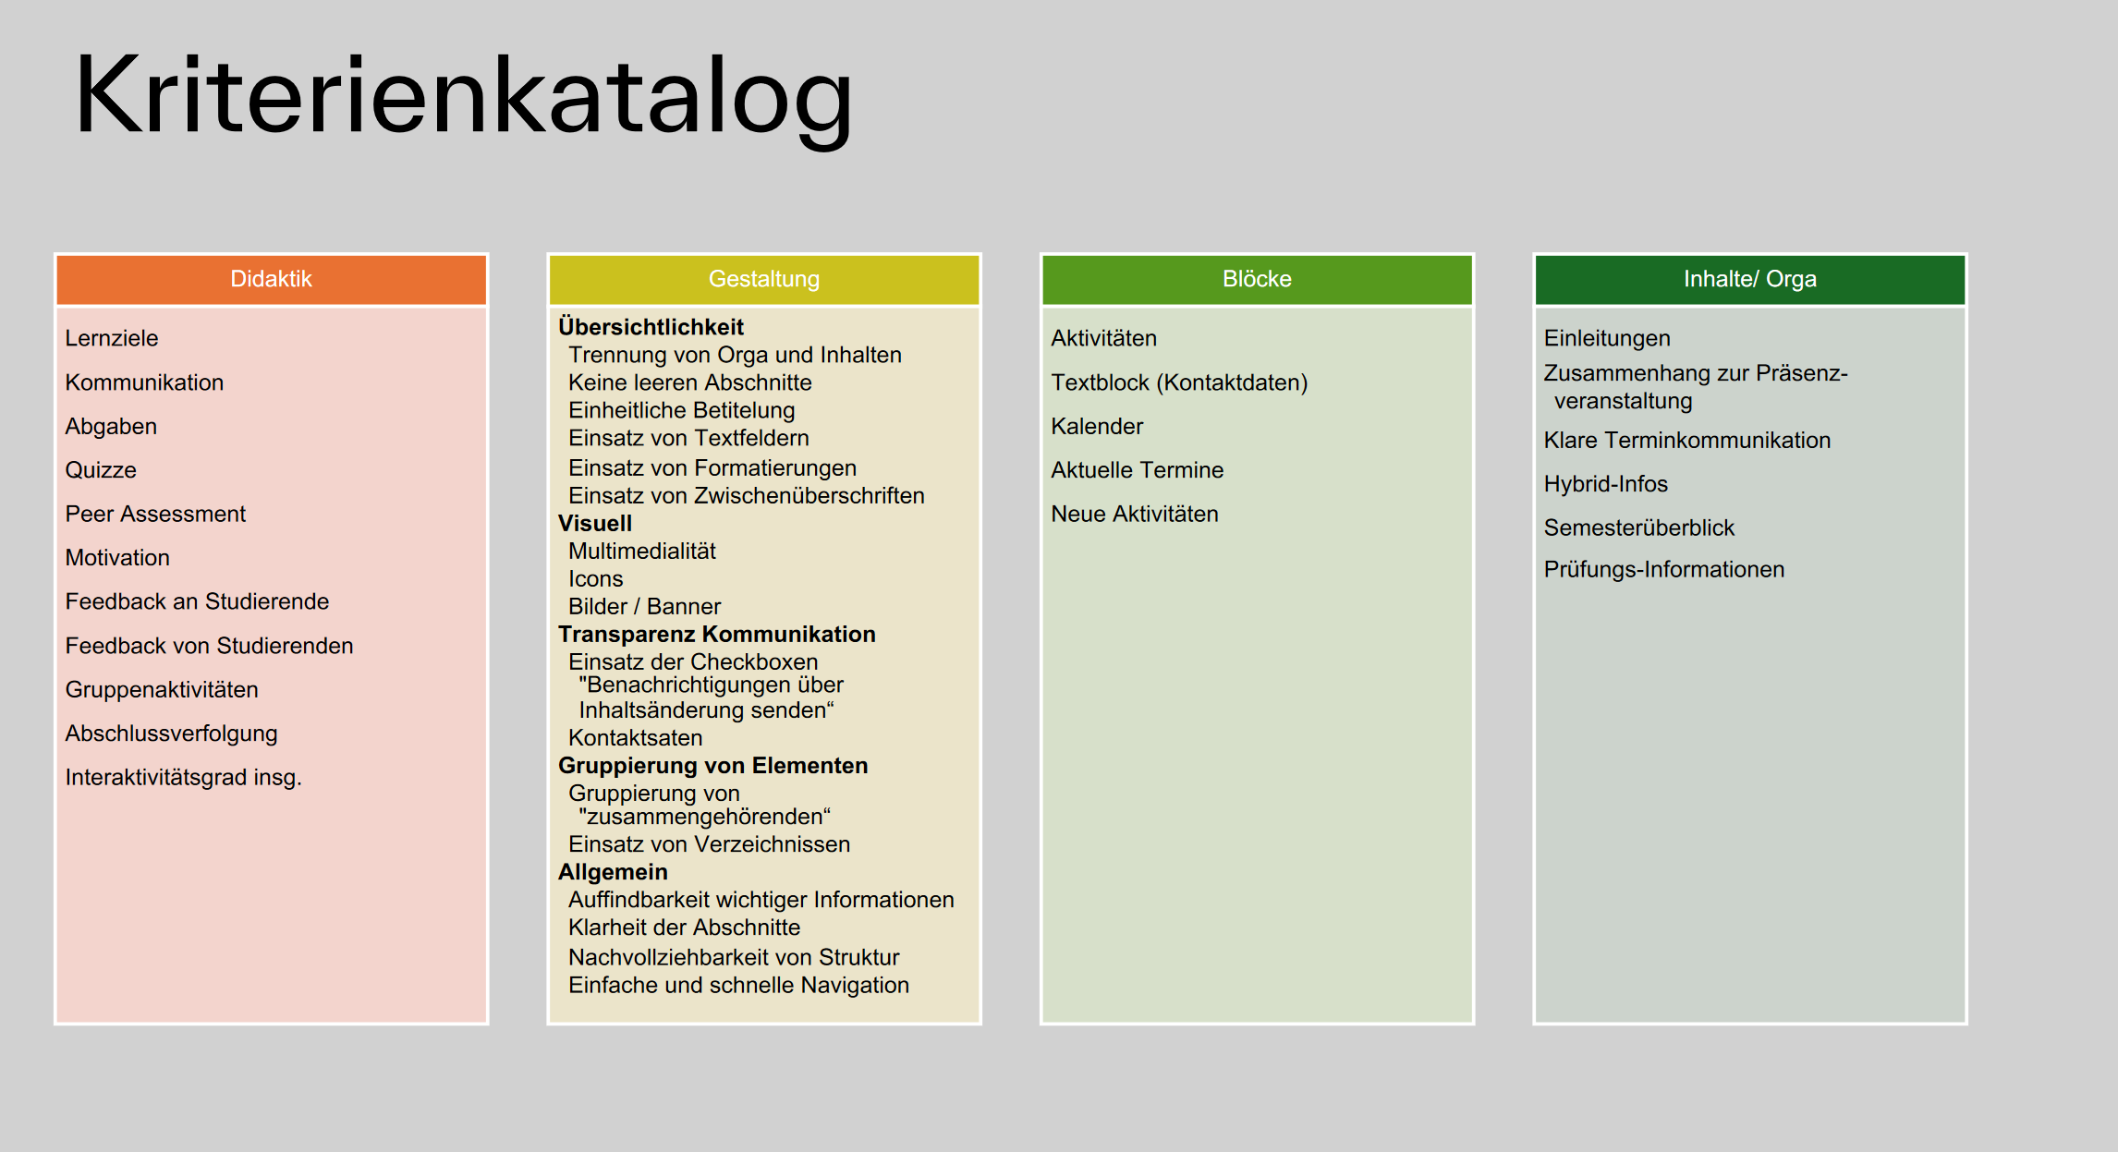
Presentation slides: https://cloud.hs-augsburg.de/index.php/s/LK2wxcnaJYdtoYT
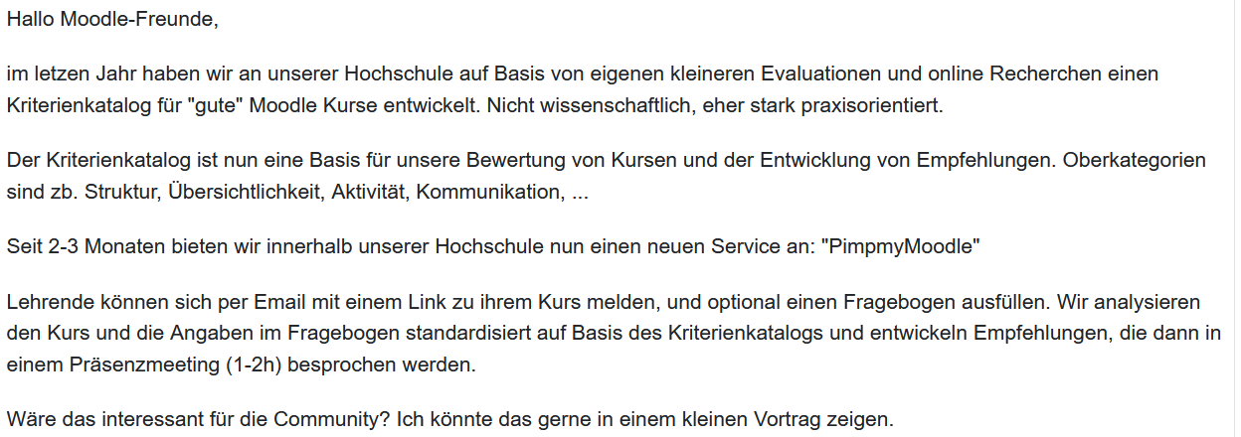
Quality assurance for moodle courses at mul?
The recommendations are roughly divided into three areas (sleek course design, clear orientation, attractive layout).
Incentive systems:
Certification, Badges. Only if you offer something that will help them.
Nicolas.romero@tha.de
https://Tinyurl.com/pimpmymoodle https://www.tha.de/Nicolas-Romero.html

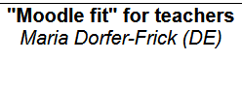https://moodlemootdach.org/mod/forum/discuss.php?d=6946
downloads: eLeDia_moodle_4_tool_guide.pdf
Provide lecturers with assistance throughout a few questions for reflection at the end of the semester
- What function should the eLearning course play in my course?- Was habe ich dafür in dem Kurs bereitgestellt?
- What was used particularly intensively?
- What has been used little/hardly/not at all?
- What have I done to ensure that it is used?
- What feedback did the students give me??
- What could I have done differently?
- How do I adapt the course for the next course?
- What do I take with me to other courses?

We recently revised the ToolGuide and also printed it as a poster: https://eledia.de/blog/eledia-blog-1/moodle-4-tool-guide-35
We are currently finalizing a planning aid for creating a course. This will end up being a fillable PDF. It guides the lecturer step by step so that he/she gets a plan.
Patrick Thibaudeau presented Cria as an AI-based solution in Moodle at the end of May. Impressive. Here is the recording: https://moodle.org/mod/forum/discuss.php?d=458899

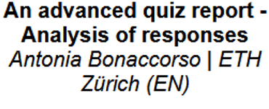
Quiz reports and analysis
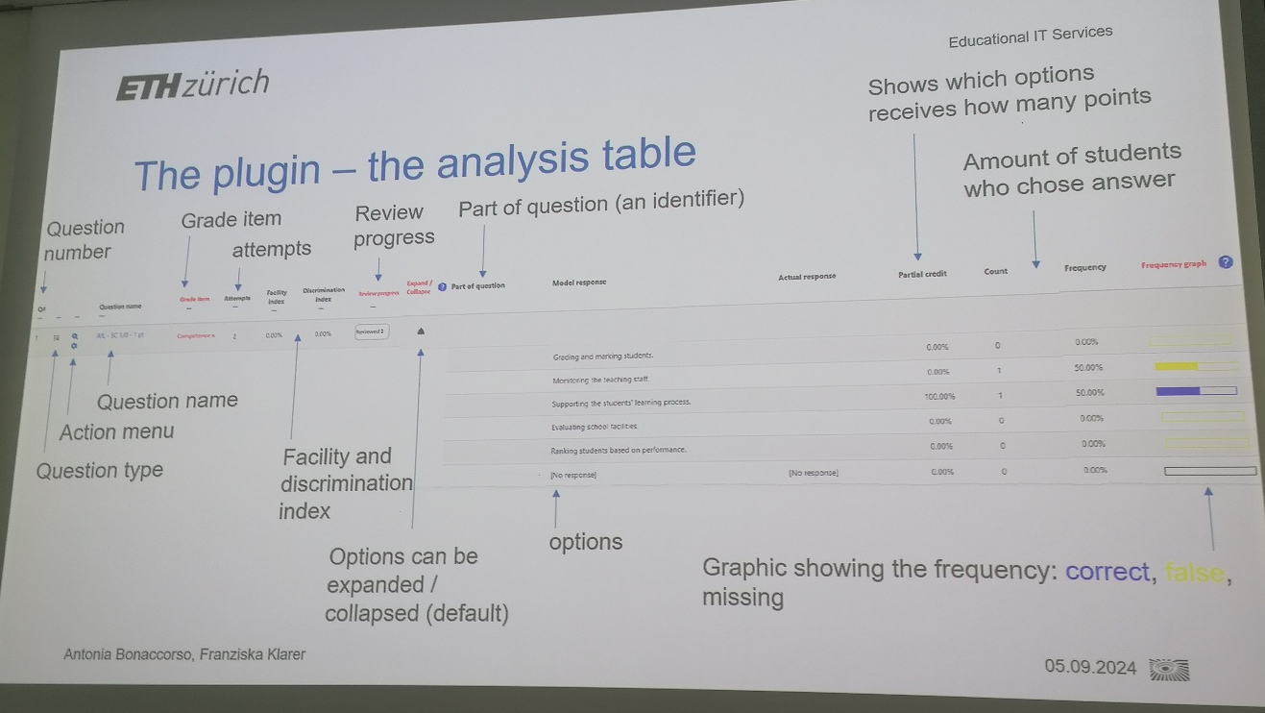
An advanced quiz report - Analysis of responses
Antonia Bonaccorso | ETH Zürich (EN)
If you are interested – please get in touch with the CTL.
__________________________________________________________________________

Further tipps:
- Glossaries are helpful, be sure to use them and let students fill them out themselves
- View requirements and progress
- Work with lessons and chapters
- Obtain feedback from students
- Accept and implement quick feedback
- Use H5P
- https://moodlemootdach.org/mod/forum/discuss.php?d=6951
- Learning paths help with orientation
- In tile view: display progress as %
- Alternative course format: Tiles, OneTopic (https://moodle.org/plugins/format_onetopic)
- Moodle.net
- Urgent questions: Students can create questions themselves and upvote other questions (prioritize)https://moodle.org/plugins/mod_hotquestion
- https://visual-books.com/moodle-kann-mehr/

