Title
Author(s)
Affiliation (Company / Institute, Adress
)

Abridged version
Text, text, text,...

Inserting sources as an end note [1].
Insert images into the running text.

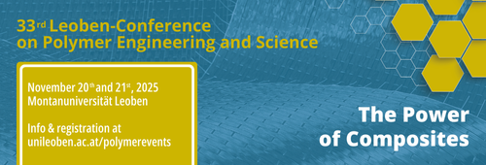
Picture 1: Caption

Acknowledgement

Literature

[] Doe J., Doe J., Doe J. (2025). The Power of Composites – Challenges and Chances in Performance and Sustainability. Proceedings of the Leoben Conference on Polymer Engineering and Science 2025, 45–52.

